
Regulations:
A15
Sreenidhi Institute of Science and Technology
(An Autonomous Institution)
Code No: 5Z443 Date: 24.4.2017

MBA II-Year II-Semester End Examination, April/May- 2017 (Regular/Supplementary)

INTEGRATED MARKETING COMMUNICATIONS

Time: 3 Hours Max.Marks:75

Note: a) No additional answer sheets will be provided.
b) All sub-parts of a question must be answered at one place only, otherwise it will not be valued.
c) Assume any missing data.

Part - A Max.Marks:25

Answer all QUESTIONS.

1. What is communication mix? [3M]

2. How do media mix elements differ in terms of reach? [3M]

3. How do you classify television commercials? [3M]

4. Give three techniques used in creating print ads. [3M]

5. What are the drawbacks of sales promotion? [3M]

6. Mention the tools involved in public relations. [2M]

7. Explain any three objectives behind launching an advertisement. [2M]

8. What is copy writing? [2M]

9. What are the advantages of publicity? [2M]

10. How are the key players in advertising? [2M]

Part – B Max.Marks:50

ANSWER ANY FIVE QUESTIONS. EACH QUESTION CARRIES 10 MARKS.

1. a. What is the role of advertising in marketing mix?
b. What is the best communication tool for creating awareness for a new brand?

2. a. What could be the objective behind designing an ad to be launched on internet/ web portals?
b. What is DAGMAR and what is it used for?

3. a. Design a message for the following illustration:

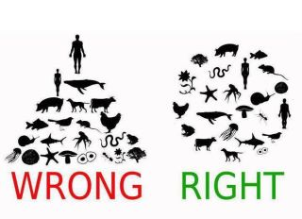
b. What are the different types of appeals in advertising?

4. a. What is broadcasting? Mention two methods of broadcasting.
b. How does the target audience of an online ad differ from target audience of T.V? Give two reasons.

5. a. How does sales promotion differ from sales force?
b. Explain any two factors influencing sales promotion.

6. a. How does publicity differ from public relations?
b. Vermillion is the agency behind the brand Patanjali. What the agency does towards Public relations?

7 a. What is marketing mix?
b. How does an advertisement differ from an advertisement campaign? Give example.

-- 00 -- 00 –

